CEN 4010 Principles of Software Engineering

Fall 2021

Milestone 4: Final Project Delivery

And Demonstration

Team G6 - Socialbuzz

Team Number: 6

Date: 12/05/2021

Rabih El Khatib - relkhatib2019 - Team Leader, Product Owner

Christopher Valera - cvalera2019 - Scrum Master

Flor Aguirre Garcia - faguirregarc2015 - Development Team

Tyler Alber – talber208 - Development Team

Kenny Demosthene - kdemsothene2018 - Development Team

History Table:

|  |  |
| --- | --- |
| 09/25/2021 | Initial Proposal |
| 10/25/2021 | Milestone 3 update |
| 11/15/2021 | Milestone 4 beta launch |
| 12/05/2021 | Milestone 5 Final Project |

**Project Summary:**

1. **Name of Product:** Socialbuzz
2. **Major Committed Functions:**

Socialbuzz aims to be a social website that brings people together. Easily accessible and intuitive, our website allows users to express themselves through customizable profile pages, as well as keep up with friends and family and the ongoing buzz in their area.

We are motivated by the challenge of creating a website that can bring something new to the table. There are many social media websites on the internet. However, Socialbuzz offers an alternative for small communities to express themselves without any fuss. Communication and information relay is something very important to us.

* Our website has a login and sign-up system in order to enter the site.
* Users are able to add profile photos, change their nickname, and add a short biography about themselves. (Implemented)
* The ability to post messages with images or gifs. (Implemented)
* The ability to follow and unfollow other users. (Implemented)
* The ability to upvote posts that you like. (Implemented)
* Buzz tab featuring news and updates about Covid and social activities and events.  
  (Implemented)
* Search feature where you can look up users. (Implemented)

1. **Unique Features:** Socialbuzz provides a quick and easy way to keep up with friends and news through it’s Social and Buzz tabs in a simple streamlined way that avoids clutter.
2. **URL to website:** [https://cen4010fa21g6.000webhostapp.com](https://cen4010fa21g6.000webhostapp.com/index.php)

**YouTube Demonstration link:**

**Milestone Documents:**

1. **Modified Milestone 3:**

**Executive Summary**

Currently, it is very important for people to stay informed about and discuss the most relevant events in their community, or simply to be able to connect with people. Our website, Socialbuzz, will allow both teens and adults of a wide variety of ages to post, discuss and report what is happening around their community. It will help strengthen relationships, recommend social events, promote small and struggling businesses, and provide social and mental health programs to people that are suffering from stress, anxiety, or any other challenges due to COVID restrictions, whether it be social distancing, quarantine, losing jobs, family, etc. Not only will the website provide these resources and updates, but users themselves can also contribute with their own stories, businesses, and findings. We aim to provide easily accessible and quick, to the point information and useful articles and resources for health, business, entertainment, and other topics. As such, the scope of this website is not necessarily limited to Covid. Although easily accessible Covid news, updates, and supporting information is one of our big priorities, Socialbuzz aims to be a socialization website where users can share a wide variety of topics and allow people to connect regardless of distance and restrictions.

**Competitive Analysis**

This analysis focused on five main features: Design, Communication, Content, Usability, Recommendations.

We have chosen 4 popular social websites and applications similar to Socialbuzz as the basis of our analysis. they were selected for their focus on local events and social networking. Below we have ranked them against Socialbuzz using a number scale (1-5) for each of the 5 features stated above:

|  |  |  |  |  |  |
| --- | --- | --- | --- | --- | --- |
|  | Socialbuzz | Twitter | Facebook | Nextdoor | Neighbors |
| Design | 5 | 3 | 4 | 5 | 3 |
| Communication | 4 | 5 | 5 | 2 | 3 |
| Content | 4 | 4 | 4 | 5 | 3 |
| Usability | 4 | 5 | 5 | 5 | 2 |
| Recommendations | 5 | 2 | 2 | 4 | 2 |
| Mean | 4.4 | 3.8 | 4 | 4.2 | 2.2 |

* **Socialbuzz (4.4):** <https://cen4010fa21g6.000webhostapp.com>

Socialbuzz has a simplistic homepage with a simple color scheme. Socialbuzz uses a search bar that uses zip code look up so you can look for events and news that is near your location. As you use Socialbuzz more it will start to recommend events in your area. Social is made with users in different age groups in mind. The content on the site is submitted by both users and staff.

* **Twitter (3.8):** <https://twitter.com>

Twitter has a very useful feature. Where you can check local hashtags and trends, using twitter’s search bar. Twitter being a large social media website makes it a good place to check for local businesses and larger events in your area. However, it can be very disorganized.

* **Facebook (4):** <https://Facebook.com>

Facebook is another big social media website. Using Facebook’s search function, you can look at local businesses for upcoming events. Facebook also has an event tab which can look at all events in the area as well as see how many people are going. Unfortunately, user privacy has been out into question

* **Nextdoor (4.2):** <https://nextdoor.com/>

Nextdoor is akin to modern day newspaper classifieds. Nextdoor lets its users mark their exact location, Nextdoor will show local news, events, local classifieds, covid events. Nextdoor makes its users verify their identity to use the app.

* **Neighbors (2.2):** <https://ring.com/neighbors>

Neighbors is an app made by the ring doorbell company. Neighbors was made with neighborhood security in mind. Neighbors lets users upload events like fires, crimes, and lost pets. Neighbors is useful to keep update on local safety issues for the users with a social media aspect added. However, it’s uses are more specialized than the other websites.

* **Planned Advantage:**

Socialbuzz is useful for users of a wide range of ages. Socialbuzz will give it users a breakdown of everything happening in their immediate area. Socialbuzz will give its users all this information in a simple and clean user space as to not overwhelm them. Socialbuzz will make it easy to communicate to other users like social media giants, but in the local space. Socialbuzz does not ask for personal information to sign up and is not affiliated with any party.

**Data Definition**

|  |  |  |  |
| --- | --- | --- | --- |
| **Name** | **Type** | **Usage** | **Meaning** |
| Accessibility | Data | Use case scenarios | How accessible the website is for disabled individuals |
| Post | Data | Use case scenarios | Messages sent by individual users on their profile page |
| Upvote | Data | Use case scenarios | users can upvote users and buzz posts they like |
| Buzz posts | Data | Use case scenarios | News feed provided the front page |
| Social posts | Data | Use case scenarios | Section where users can view posts by other users they follow as well as popular posts |
| Search | Service | Site user service | Allow users to easily find what they are looking for by searching specific terms or tags |
| Socialbuzz | Domain name | Use case scenarios | Domain name that all the webpages of the site are under |

**Overview, scenarios and use cases**

The internet has revolutionized communication, to the point that it has become the most important way of communication by young people, adults, and elderly. Websites have become the most powerful tool to interact with other people and stay informed of the events and main news of the community converting a user as commentators, editors, creators, and publicists.

**Use case 1:** User wants to share an interesting article they’ve read regarding health and safety. User can log in and head to the Buzz tab look for posts titled “Health”.

**Use case 2:** Another user finds the post useful and wishes to spread awareness on it. User can upvote the post on the buzz page which will be reflected in the number of upvotes on the post.

**Use case 3:** A user would like to share something they found on their way back hope. The user can log in, head to their profile page and post a message about their finding with an attached image that can be uploaded directly from their mobile phone.

**List of high-level functional requirements**

* Fully functional Login and Sign-up system with safely encrypted user passwords.
* Profile page where users can post messages, edit profile pictures as well as add a short bio about themselves.
* Follow and Follow feature that determines which other user posts appear on a user’s social page. Socialbuzz will also recommend people for you to follow.
* Buzz page populated with news as well as user posts that will be consistently updated.
* Simple search functionality for usernames which will allow users to easily find other people on the site.
* Social page where a user’s posts and photos are posted and can be viewed by their followers.
* Upvote system for social posts and buzz posts. The highest upvoted posts will be featured on the front page based on simple algorithms
* Users can follow other users to have their posts appear on their user feed.
* Post message feature where users can post messages that will show up as social posts for other users who follow them.

**List of non-functional requirements**

* Compatibility: We aim to have Socialbuzz be compatible with any modern electronic device that supports web browsers. That includes devices of varying sizes from large personal computers to smaller laptops and tablets, all the way down to smartphones. Using bootstrap, we aim to create a fully functional responsive front-end.
* Accessibility: The UI will be kept simple and easily approachable for disabled users, and voice read functionality will be implemented for blind users.
* Maintainability: Socialbuzz will be maintained through a free online webhosting service. As such the website will stay active as long as required. Buzz page is maintained by staff, and user pages can be freely handled by users.
* Security: the website will not ask for any personal information from the user such as phone numbers or identification and will operate on a secure username and password system. Passwords are encrypted using hash functionality.

**High-level system architecture**

1. Languages: HTML, CSS, JavaScript, PHP, AJAX

Database: MySQL, phpMyAdmin

Compatible Navigators: Chrome, Microsoft Edge, Firefox, and other web browsers

2) DB organization: MySQL database through phpMyAdmin

Tables:

* users: id (PRIMARY KEY), name, username, email, password, img, bio.
* posts: posts_id (PRIMARY KEY), content, img, title.
* postdate: id (PRIMARY KEY), user_id (Index), post_on.
* likes: id (PRIMARY KEY), user_id (Index), post_id (Index).
* follow: id (PRIMARY KEY), follower_id (Index), following_id (Index), time.

3) Media will not be stored in the database and will instead be uploaded to the webhosting  
service. Media and will be directly accessed from users’ file systems.

4) Search functionality employs AJAX PHP to create an interactive and responsive search system to find other users. The search functionality will find other users matching the user input and generate a dropdown list of profiles that can be clicked by the user. For security purposes, the user cannot send inputs, and is only able to click on the profile from the dropdown boxes.

**High-level UML Diagrams**

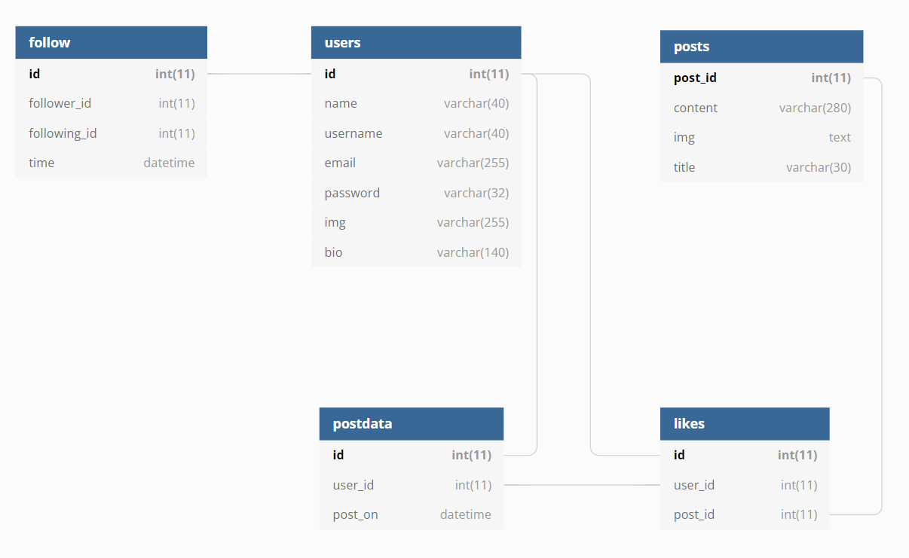 Classes Diagram

Use Case Diagram

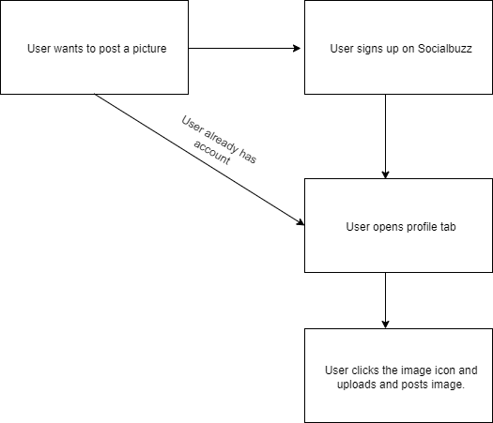

**Risks**

1. Skill risk: Team is not very experienced using php and MySQL. We plan to resolve this by prioritizing working on backend aspects of the project first.
2. Schedule risk: We are unsure how much we’ll be able implement from the features that we initially intended. We plan to work around this by focusing on one aspect at a time.
3. Teamwork risk: We are working together to the best of our ability on the project and are cooperating to finish at the deadlines given
4. Legal risk: We intend to only use public domain images and content from Government websites or other potential places.
5. **Milestone 3 & 4 Feedback Summary:** Feedback for Milestone 3 includes providing more detail when it comes to scenario and use cases, both high-level functional requirements and non-functional requirements, high-level system architecture (UML), as well as to add Technical, teamwork, and legal/content risk sections.  
   Milestone 4 feedback includes providing an overview of the functionalities and why those are good in the Product/Project Summary section, as well as to elaborate further on best practices and security.

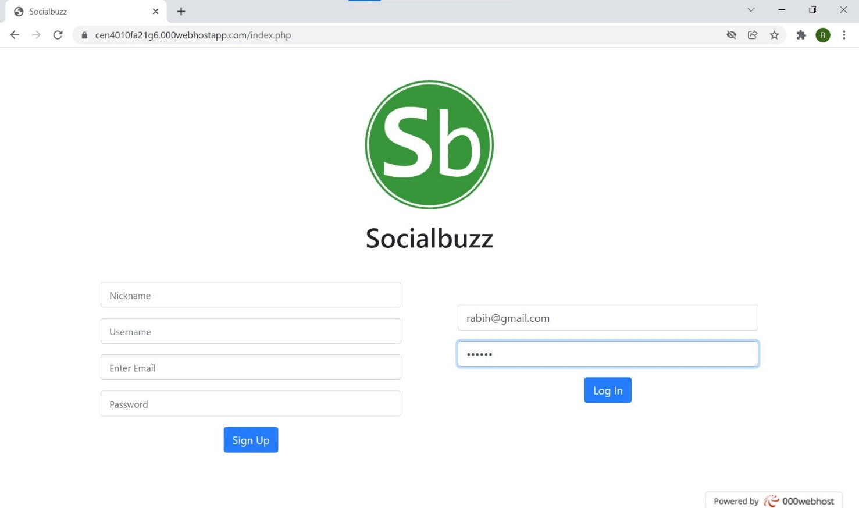**Screenshots of actual final product as shown in the demo:**

Login and Sign-up page

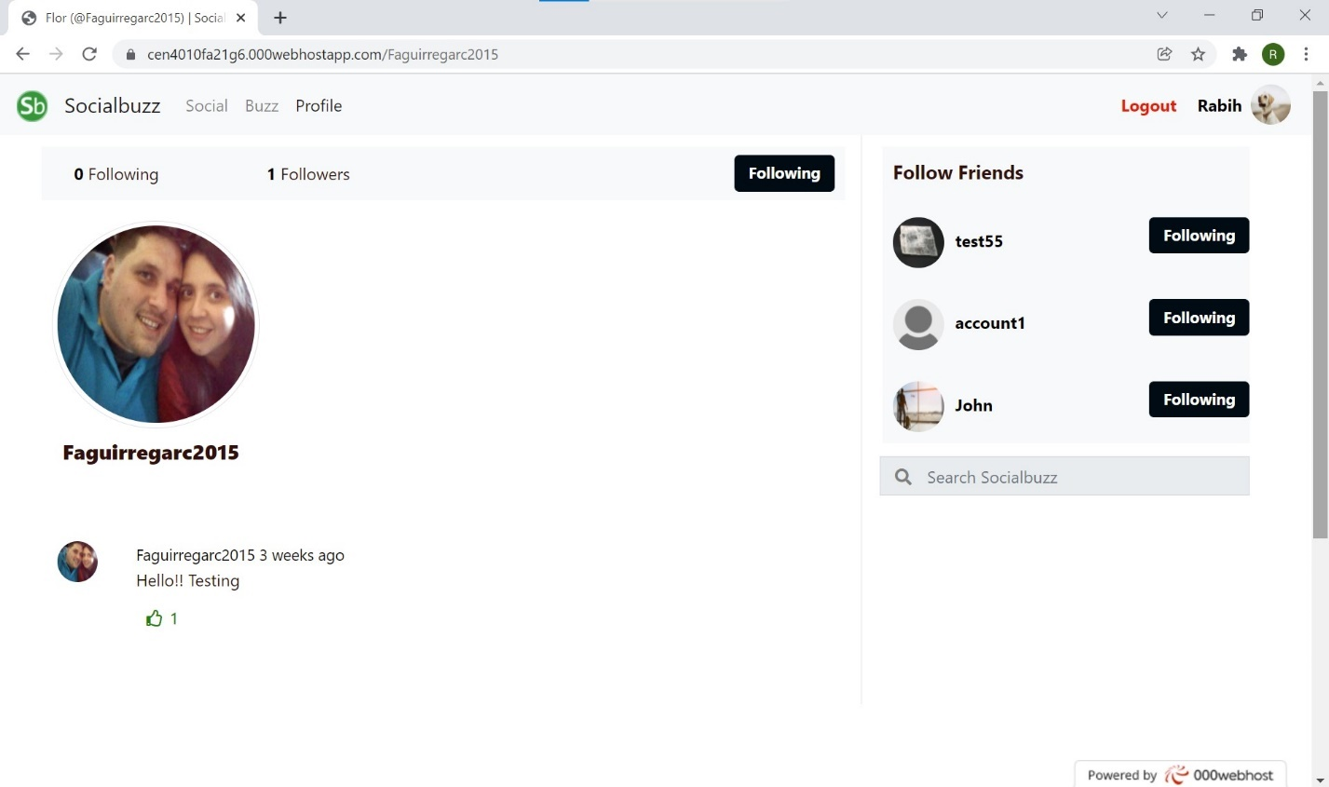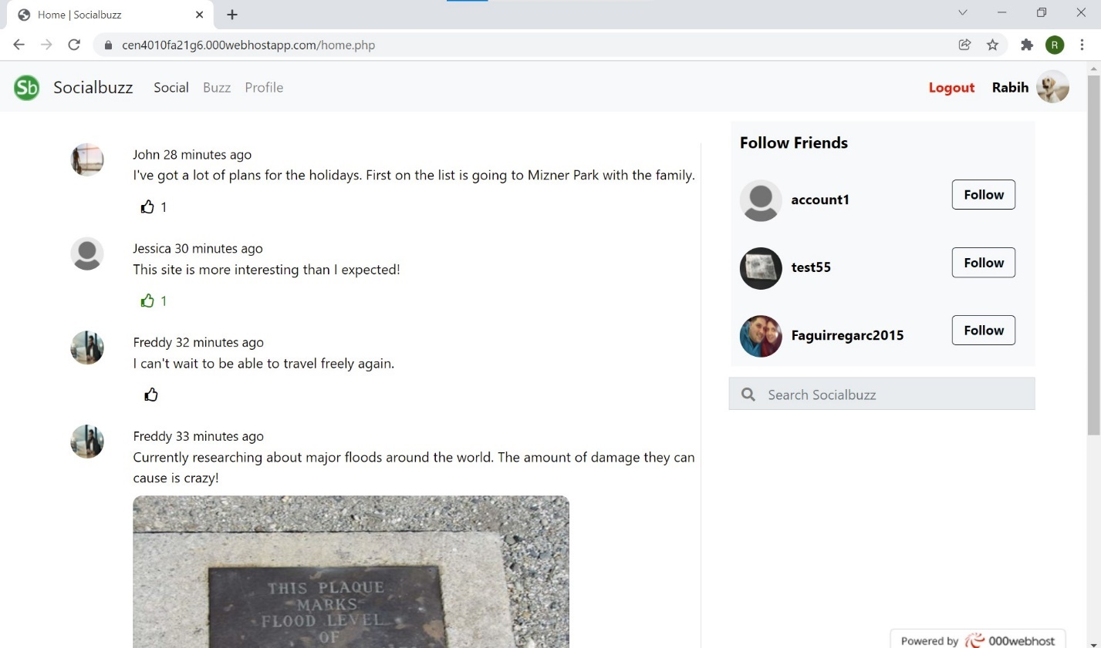

Another user page and follow

Social page

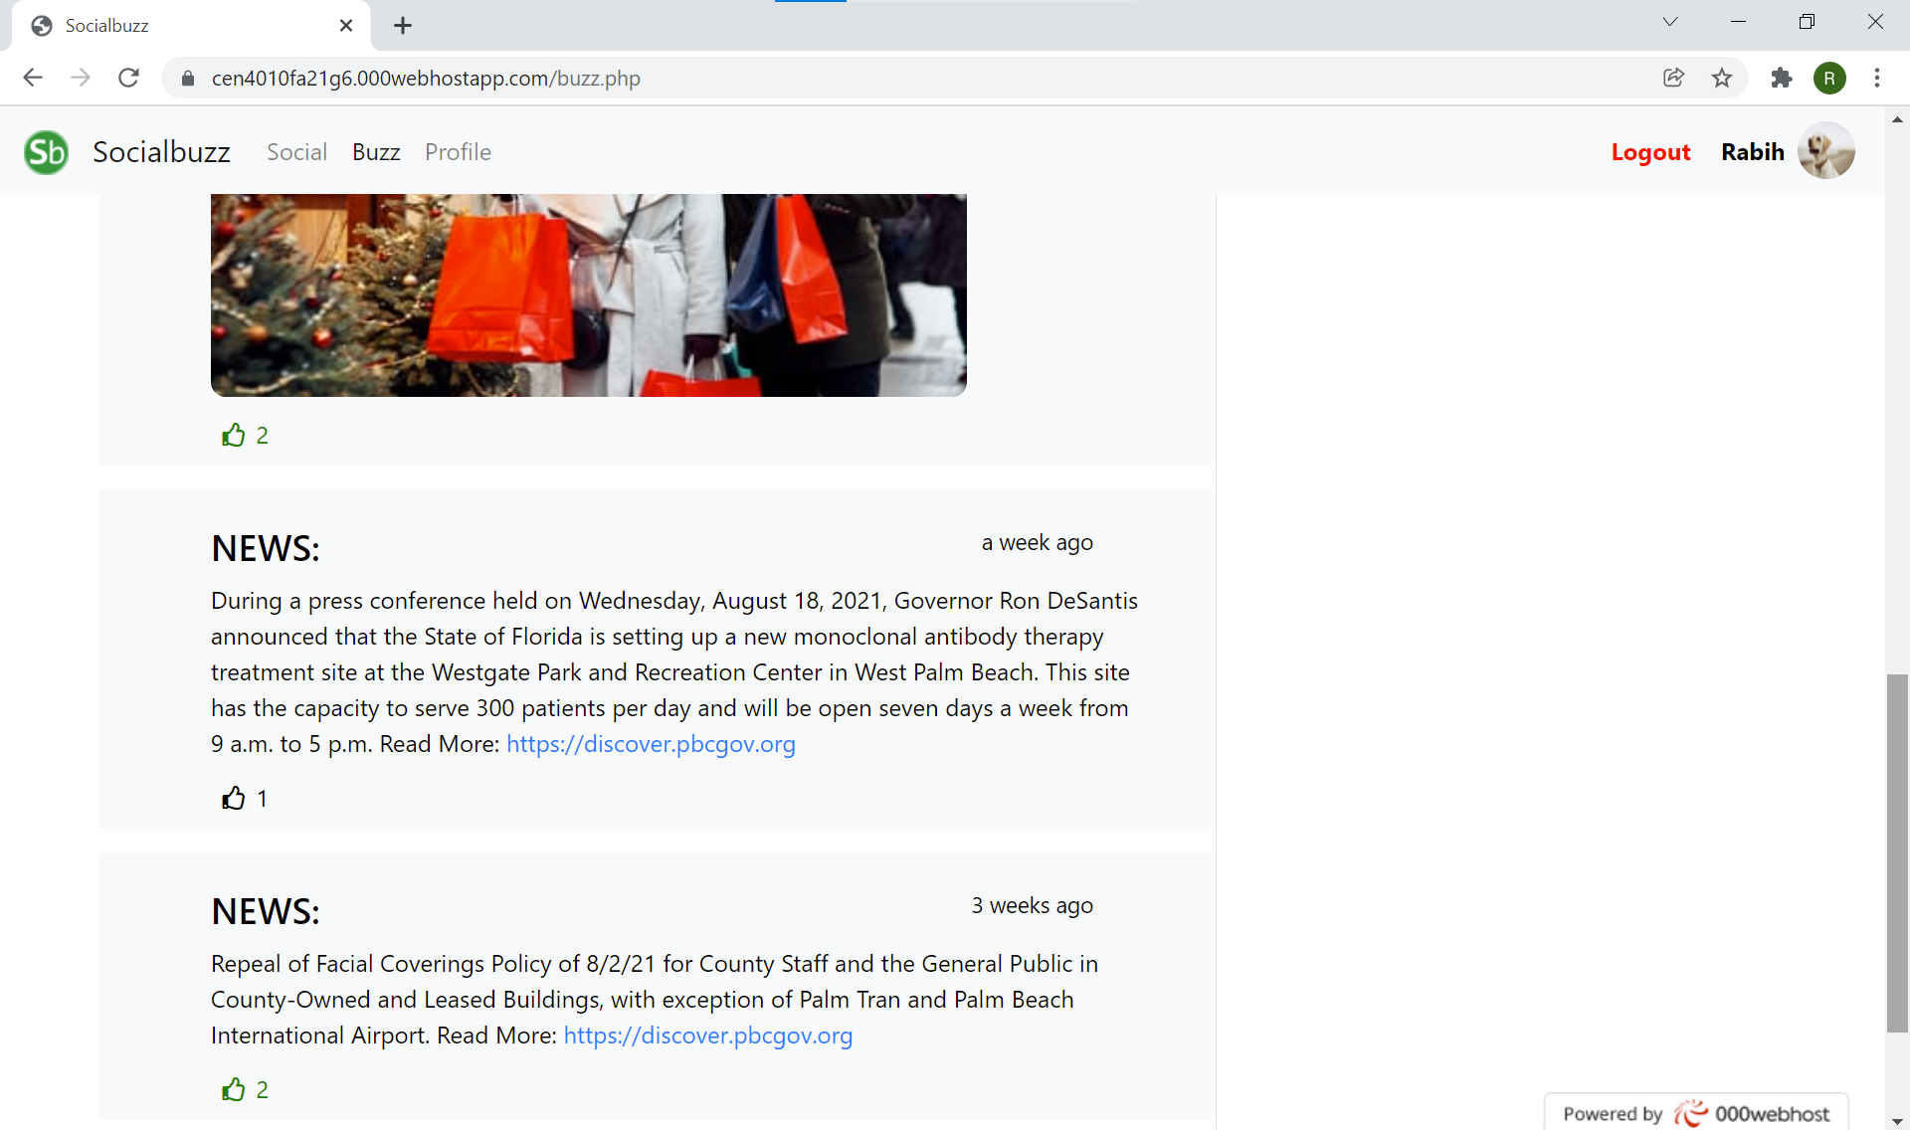 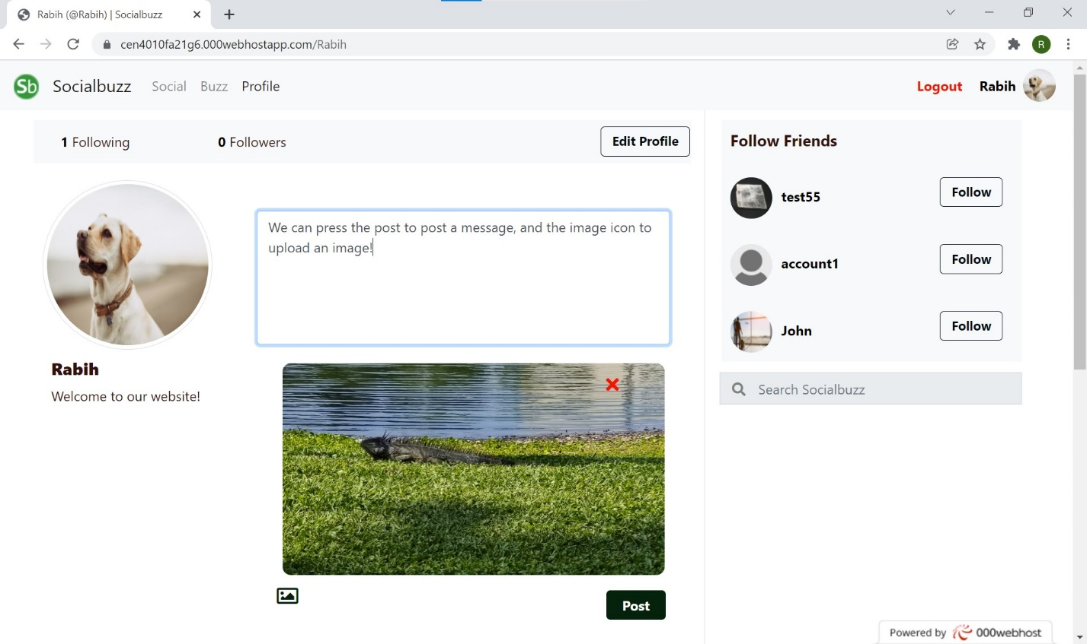

News Buzz posts

Posting a message with image

**Google Analytics Plot:**

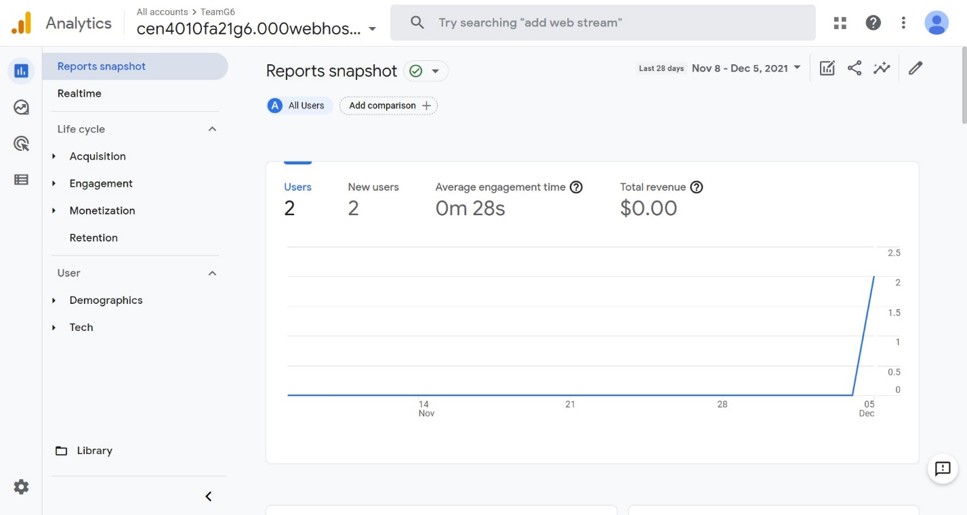Realtime Plot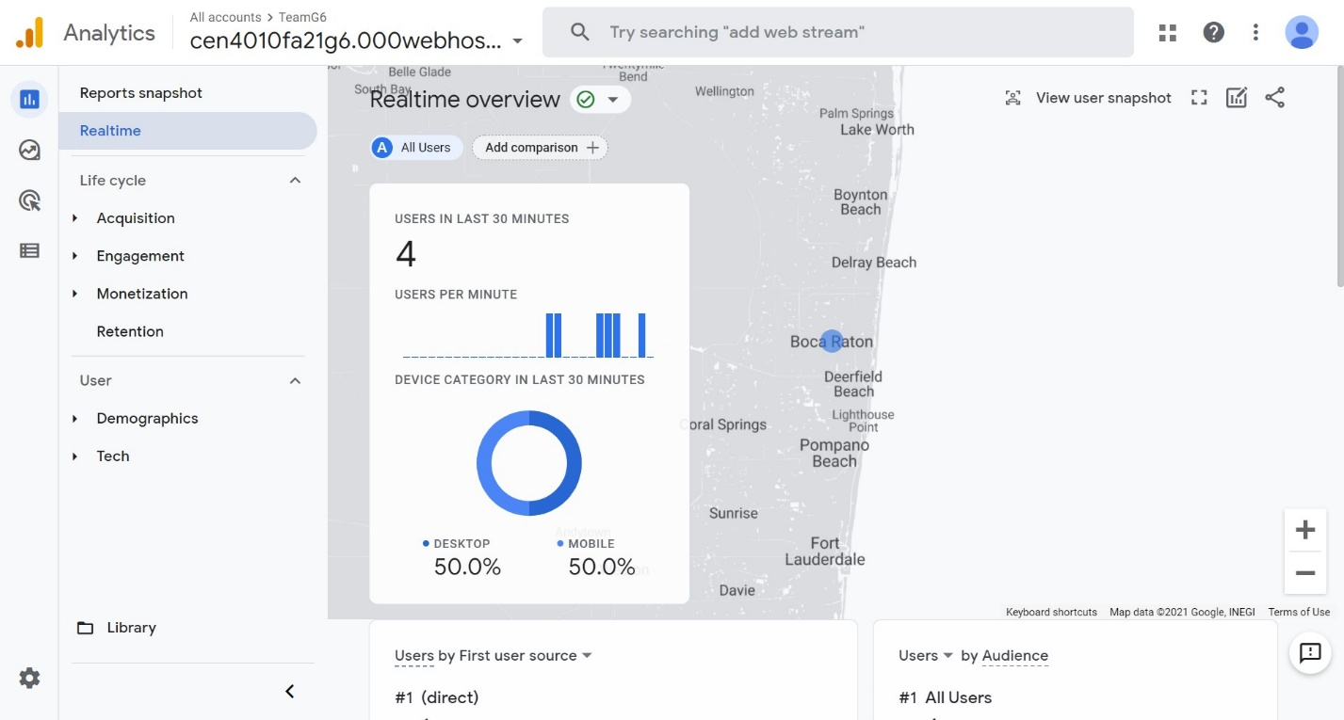

Reports Snapshot

**Team Members Contribution:**

1. **Members Contribution to Project:**

Rabih: Team Leader, Project Developer, Manager, Tester (22 Points)

Chris: Scrum Master, Project Conceptualization (21 Points)

Flor: Tester, Project Support (20 Points)

Kenny: Project Support (18 Points)

Tyler: Project Support (19 Points)

1. **Members Contribution to Teamwork:**

Rabih: Assigned tasks to the team. Contributed to team meeting scheduling, project mock-up, vertical slice, development, and backend. In charge of writing and supervising milestones, project analytics, demonstrations, and presentation.

Chris: Contributed to project conceptualization, analysis, meeting scheduling, milestone writing support and data gathering.

Flor: Contributed to project conceptualization, milestone writing support, data gathering and testing.

Kenny: Contributed to data gathering.

Tyler: Contributed to data definitions.

1. **Number of Github Submissions**

Rabih: 42 commits

Chris: 3 commits

Flor: 2 commits

Kenny: 0 commits

Tyler: 1 commits

**Post-Project Analysis:**

**Main Challenges:** The biggest hurdle in for this project was skill level. Most of the time was spent learning how to connect between PHP and MySQL, creating the project back-end, as well as extensive testing to make sure our functionalities work. Another problem was organization and scheduling since it was very difficult have online meetings with the team having conflicting schedules. One major reason that led to this was difficulty in estimating how long a task or issue would take to complete which also led to us often being behind schedule and forcing us to cut certain planned features.

In the future, I think it’s important to access very early on the skillset of every team member and assign roles quickly. In addition, we should start prototyping as soon as possible. It is better to start small then go big.

**Features:** We were able to complete a large number of features including a login/signup system, a post feature with images or gifs, an upvote feature, a follow feature, an edit profile feature, as well as a username search feature. There were certain features we had to remove due to time constraints, such as a post search feature as we were only able to implement search functionality for usernames, as well as a feature where an algorithm will recommend posts to you on your Social feed based on number of likes and the date the post was made. It proved to be technically difficult and we had to settle for posts on your feed only showing up only from users your follow. Last major feature we couldn’t implement was video posts because the webhost we are using limited us to 300 MB of data and we feared it could slow down the site if poorly implemented.

**Knowledge:** The experience working on this project has taught us many things both functionally and non-functionally. We have learned a lot about how the web operates and what goes into making a moderate to large scale website. From a technical side, we furthered our HTML, CSS, PHP, JAVASCRIPT knowledge greatly, and the usage of GitHub proved to be a great experience and learning process. We also learned about the difficulties that come with making such a project, especially when it comes to project management, scheduling and organization.